परमाणु ऊर्जा केन्द्रीय विद्यालय, नरौरा
Atomic Energy Central School, Narora
Newsletter
April 2019 to July 2019
April- 2019 Session
To 2019-20
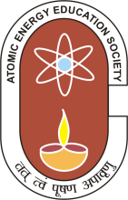
July-2019

Patron Chief Editor
Shri Neeraj Kumar Blahatia Shri Tarun Kush
Principal Vice-Principal
Editor: S. K. Sharma, (Librarian) Mrs. Sunita Sharma (TGT-SG)

OUR MISSION
AECS, Narora Strengthens and encourages its students with knowledge, attitude, worldliness, patriotism, moral strength, rich culture of India and instills in them strong feelings forwards eradication of differences based on caste, creed, gender, religion and languages.
Academic performance of the students in AISSCE and AISSE -2018 -19

Class X
Students Strength : 90
Pass percentage (%) : 98.89
Quality index (Q.I.) : 7.71
Excellence index (E. I.) : 85.56
Class XII
Students Strength : 65
Pass percentages (%) : 93.85
Quality index (Q.I.) : 7.74
Excellence index (E. I.) : 87.69

CLASS XII - School Toppers CLASS X - School Toppersf
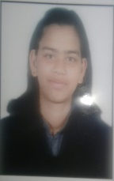
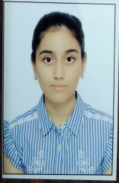
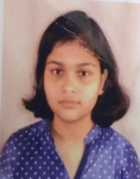
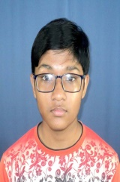
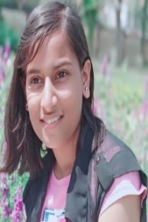
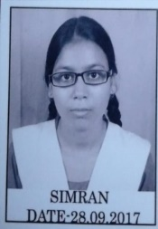
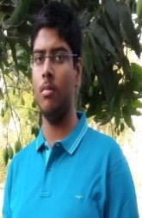
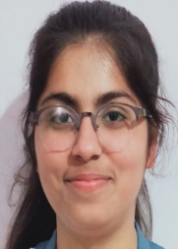
First 96 % Second 92% Third 91.8% First 97.6% Second 96.6% Third 96.4%

MEGHA ARORA ASHI SIMRAN KUSHI SHARMA SUCHITA ANANT PAKHI PRATIKSHA
SUBJECT TOPPERS CLASS 12TH
SUBJECT | NAME | % | SUBJECT | NAME | %
English | Payal | 99 | Bio | Kushi Sharma | 99
Hindi | Manya Yadav | 99 | Computer sci. | Raghav Maheshwari | 97
Chemistry | Raghav Maheshwari  Vashita Bhardwaj  Itesha Goyal  Kushi Sharma  Chesta Gupta  Simran | 95  95  95  95  95  95 | Physics | Simran | 95
 |  |  | Mathematic | Magha Arora | 97
 |  |  | Accountancy | Megha Arora | 96
 |  |  | Economics | Megha Arora | 100
 |  |  | Bus. study | Megha Arora | 91
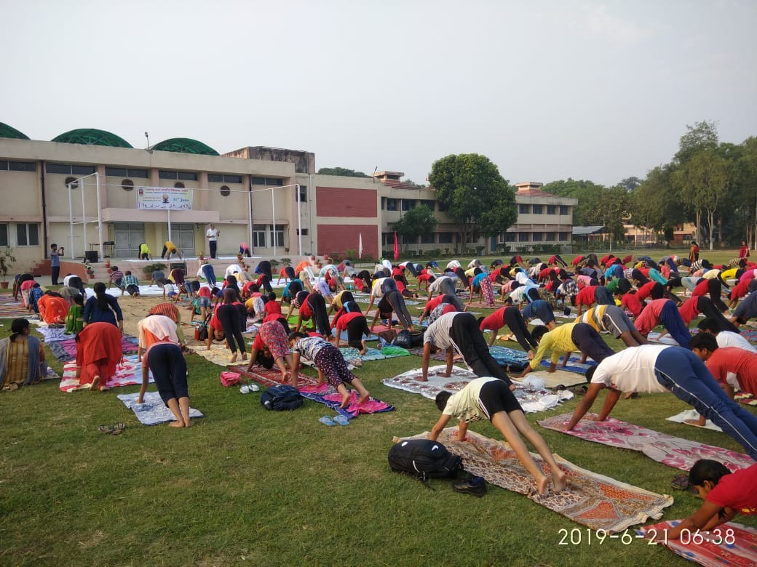
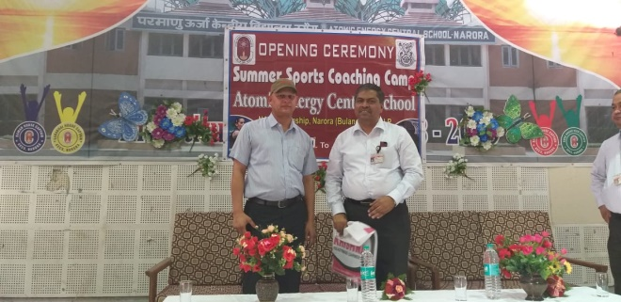
Summer Sports Coaching Camp: It was held from 20th April to 10th May 2018 for 21 days. Preliminary Camp was held from 3rd April to 9th April 2018 for 7 days. In which selection trial for the students was held. Total 75 No. of students were selected, in main camp in 3 disciplines i.e. Basketball, Badminton and Football. 25 students in each game 11 Boys and 14 Girls in Basketball, 13 boys and 15 girls in Badminton and 22 boys were selected in Football from main Coaching Camp. 3 (three) outside Coaches were deputed for coaching the students. Nutritious refreshments were provided to students, T –shirts and Shorts were also given to tem in which shorts were sponsored by NAPS Narora .Opening ceremony and kit distribution was done by L.M.C Chairman Mr. A.K Dutta and closing ceremony and certificate distribution was done by Mr. Raichur C.S. N.A.P.S.
Celebration of 5th International Day of Yoga on 21st June, 2019: The practice/rehearsal session began on 17. 06. 2019 and continued till 20.06.2019 daily from 0600 hours to 0715 hours in the school playground (senior secondary building). The staff and the students acquired the correct methods/techniques of performing various yoga postures (standing, sitting, lying), kapalbharti, Pranayam, Dhyana / meditation and surya namaskar under common yoga protocol. On 21st June, 2019 all the staff and students arrived in the School playground of the senior secondary building at 0600 hours.
Total yoga participants of 825 students, staff, LMC Chairman and members of LMC, officers and employees of NAPS participated in the 5th International Day of Yoga on 21.06.2019. Thereafter, snacks (200 ml of buttermilk or chhachh, 1 banana, 1 packet of biscuit) were distributed to all the yoga participants. The yoga practice/rehearsal session was carried out on 21st June under the guidance of Mr. S. K. Sharma (Librarian) a yoga instructor.
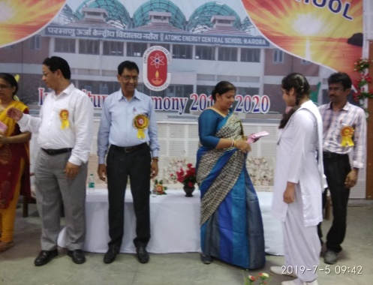
INVESTITURE CEREMONY: 05 July 2019, Investiture Ceremony symbolizes Badge giving Ceremony. School
Students were divided into four Houses. I.e. Bhabha, Bose, Raman and Sarabhai. All houses were their representations and school heads. All the selected members /students were facilitating by giving badge, our honourable Station Director Shri A.K Dutta was the chief guest and Mrs. Shivani Dutta was the guest of Honour. During this ceremony student were got the badge of captain, vice-captain, house captain, sports captain, assembly captain in both primary and secondary. School Level: Science, Social Science, Mathematics and Teaching Aids exhibition – 2019:
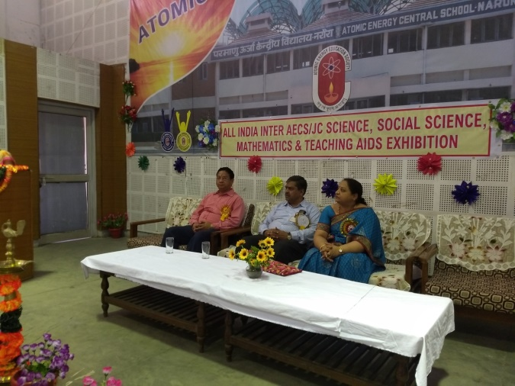
We organized School level Science, Social Science, Mathematics and Teaching Aids exhibition -2019 on Tuesday 09 July 2019. Sh. P. G. Raichur, CS NAPS and member LMC was the Chief Guest on the occasion. Mrs. Lakshmi Raichur was the Guest of Honour. There was a Panel of 09 judges for the judgement of exhibits. Students showed their scientific skill a and talent in exhibits right from those saving ecosystem, robotics, those involving energy transformation. Students were very enthusiastic and participated in good numbers at the School level exhibition. There were total 225 exhibits in 6 different categories.

